**31-01-2018**

**RESEARCH INFOTECH**

**DAILY ANALYSIS**

|  |
| --- |
| http://researchinfotech.co.in/storage/images/logo.pngImage result for SEBI |

|  |
| --- |
| **INDIAN HOTELS COMPANY LTD (NSE-INDHOTEL)** |

|  |  |  |
| --- | --- | --- |
| **BUY** | **141-142** | **SL-130** |
| **TGT 1- 150** | **TGT 2- 160** | **SL-130** |

|  |  |  |  |  |
| --- | --- | --- | --- | --- |
| **S2** | **S1** | **PP** | **R1** | **R2** |
| **640** | **690** | **730** | **760** | **820** |

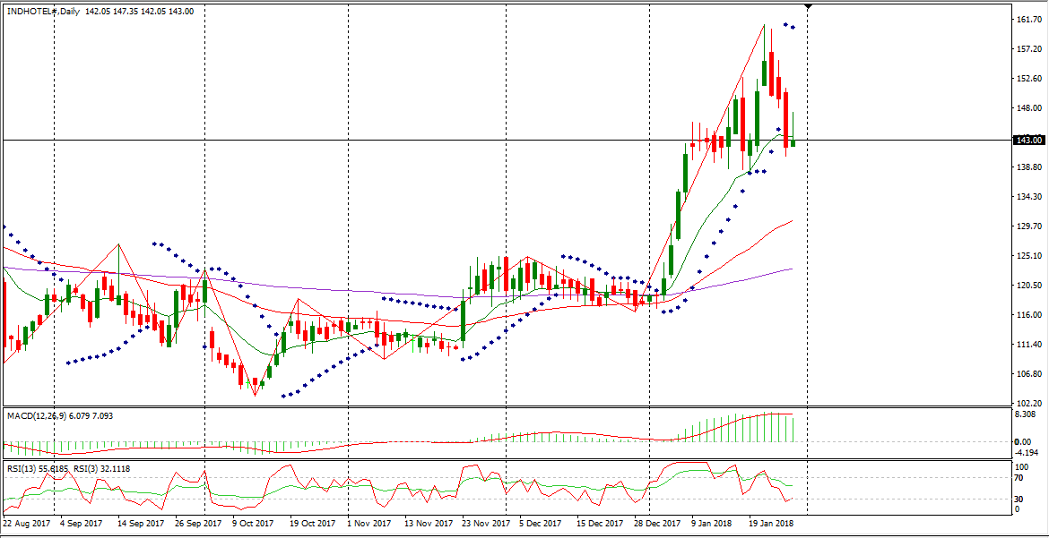

**DESCRIPTION**

The Indian Hotels Company Limited is a holding company. The Company is engaged in short-term accommodation activities, and restaurants and mobile food service activities.   
The Company is primarily engaged in the business of owning, operating and managing hotels, palaces and resorts. The Company's segments include Hoteliering and Others, which consists of air catering and investing activities. Its area of business includes Taj, Taj Safaris, Vivanta by Taj, The Gateway Hotel, Ginger, and Taj Trade and Transport.  
 Its other areas of business include Taj Air. The Company has approximately 110 hotels in over 60 locations, including over 25 Ginger hotels across India, with an additional approximately 20 international hotels in the Maldives, Malaysia, Australia, the United Kingdom, the United States, Bhutan, Sri Lanka, Africa and the Middle East.  
Its subsidiaries include TIFCO Holdings Limited, KTC Hotels Limited, Lands End Properties Private Limited and Sheena Investments Private Limited.

|  |
| --- |
| http://researchinfotech.co.in/storage/images/logo.pngImage result for SEBI |

**TECHNICAL VIEW**

* In daily candle INDHOTEL was looking strong, it was taking support of its 200 day’s EMA and looking reversal.
* From the opening it was falling down but near closing continuous fresh buying it took support of its short term moving average and I saw fresh buying near closing.
* In short term its structure was also looking bullish.
* In daily candle made an inverted bullish hammer and tend to reversal, next trading it can be gap up opening.
* Above its moving avg it made a bullish candle in daily candle stick chart pattern.
* Its daily candle I saw it made three bearish breakaway also.

**RECENT NEWS**

* Indian Hotels Company Ltd (INDHOTEL, 500850) Stock & Share Price Update With Analysis - January 30, 2018.
* During the final trading hours Indian Hotels Company Ltd. was seen to be priced at Rs.143.55 while being 2.15 points above the day’s lowest and 3.8 points below the day’s highest. With this, the day's high was Rs.147.35 and the day's low was Rs.141.40.
* Volume Moving the Tape 3.64% For The Indian Hotels Company Limited (INDHOTEL.NS)  
  A total of 356,294 shares were traded by this time of the day with the 5 day average volume being 498,529 , 10 day average volume being 587,128 and 30 day average volume being 1,270,700 .
* The Indian Hotels Company Limited (INDHOTEL.NS) currently has a 14-day Commodity Channel Index (CCI) of -19.30. Active investors may choose to use this technical indicator as a stock evaluation tool. Used as a coincident indicator, the CCI reading above +100 would reflect strong price action which may signal an uptrend. On the flip side, a reading below -100 may signal a downtrend reflecting weak price action. Using the CCI as a leading indicator, technical analysts may use a +100 reading as an overbought signal and a -100 reading as an oversold indicator, suggesting a trend reversal.
* The RSI, or Relative Strength Index, is a widely used technical momentum indicator that compares price movement over time. The RSI was created by J. Welles Wilder who was striving to measure whether or not a stock was overbought or oversold. The RSI may be useful for spotting abnormal price activity and volatility. The RSI oscillates on a scale from 0 to 100.

## **DISCLOSURE**

RESEARCH INFOTECH DO NOT RECEIVE ANY CONSIDERATION BY WAY OF REMUNERATION OR COMPENSATION OR IN ANY OTHER FORM WHATSOEVER, BY US OR ANY OF OUR ASSOCIATES OR SUBSIDIARIES FOR ANY DISTRIBUTION OR EXECUTION SERVICES IN RESPECT OF THE PRODUCTS OR SECURITIES FOR WHICH THE INVESTMENT ADVICE IS PROVIDED TO THE CLIENT.

RESEARCH INFOTECH DO NOT RECOMMEND A STOCK/COMMODITY BROKER. IF ANY STOCK/COMMODITY BROKER IS RECOMMENDED BY ANY OF OUR REPRESENTATIVE, WE DO NOT RECEIVE ANY CONSIDERATION BY WAY OF REMUNERATION OR COMPENSATION OR IN ANY OTHER FORM WHATSOEVER FROM STOCK/COMMODITY BROKER OR ANY OTHER INTERMEDIARY SO RECOMMENDED TO CLIENT.

TO ENSURE COMPLIANCE WITH THE INVESTMENT ADVISOR REGULATIONS 2013, WE HAVE RESOLVED THAT THE INVESTMENT ADVISOR AND ALL ITS REPRESENTATIVES WILL NOT MAKE ANY TRADES IN THE MARKET. WE ARE NOT ASSOCIATED IN ANY MANNER WITH ANY ISSUER OF PRODUCTS/ SECURITIES, THIS ENSURES THAT THERE IS NO ACTUAL OR POTENTIAL CONFLICTS OF INTEREST. THIS ALSO ENSURES THAT OBJECTIVITY OR INDEPENDENCE IN THE CARRYING ON OF INVESTMENT ADVISORY SERVICES IS NOT COMPROMISED. INVESTMENT IN STOCK/COMMODITY MARKETS IS SUBJECT TO MARKET RISK, THOUGH BEST ATTEMPTS ARE MADE FOR PREDICTING MARKETS, BUT NO SURETY OF RETURN OR ACCURACY OF ANY KIND IS GUARANTEED, WHILE THE PERFORMANCE SHEET OF VARIOUS PRODUCTS IS AVAILABLE BUT SHOULD NOT BE CONSIDERED AS A GUARANTEE FOR FUTURE PERFORMANCE OF THE PRODUCTS/SERVICES. CLIENTS ARE ADVISED TO CONSIDER ALL THE ADVICE AS JUST AN OPINION AND MAKE INVESTMENT DECISION ON THEIR OWN.

IN CASE OF CLIENTS SEEKING ADVICE ON ANY SPECIFIC POSITIONS ALREADY MADE BY THE CLIENT, WE WILL BE ABLE TO SUGGEST BEST POSSIBLE ACTION CONSIDERING OUR VIEW ON THE SECURITY OR PRODUCT. SUCH SUGGESTION UNDER ANY CIRCUMSTANCES SHALL BE CONSIDERED AS AN OPINION (NOT ADVICE) FROM OUR ORGANIZATION AND WE ADVISE CLIENT TO CONSIDER OUR OPINION AND NOT CONSULTANCY TO MAKE HIS/HER FINAL DECISION. WE ARE NOT LIABLE FOR ANY LOSSES WHATSOEVER CLIENT MAY INCUR IN ACCEPTING THIS OPINION.

CLIENT IS ALSO ADVISED TO TRADE ONLY IF TIPS SUIT HIS CURRENT RISK APPETITE AND RISK BEARING CAPACITY, ALL SUCH TIPS SHALL BE CONSIDERED AS A VIEW OR OPINION AND CLIENT SHALL ON HIS/HER DISCRETION DECIDE ACTUAL TRADES.

WE ARE NOT ASSOCIATED WITH ANY INTERMEDIARIES AND DO NOT RECOMMEND SERVICES OF ANY SPECIFIC INTERMEDIARIES.  
NO LITIGATIONS HAVE BEEN FILED AGAINST US SINCE THE INCORPORATION.

ALL THE TIPS WHICH ARE SUGGESTED BY US ARE COMMUNICATED IN WRITTEN, NO VERBAL COMMUNICATION FROM ANY OF THE EXECUTIVES OR OTHERWISE UNDER ANY CIRCUMSTANCES SHALL BE CONSIDERED AS ADVICE BY OUR ORGANIZATION.